

**Assignment 1 Data Visualization**



**GLA data 1**

**aneta Abazay**

**2022**

Table of Contents

Task 1 2

Task 2 3

Task 3 12

# Task 1

Policies and Procedures

* Computer Misuse Act 1990​
* Police and Justice Act 2006 (Computer Misuse)​
* Copyright, Designs and Patents Act 1988​
* The Copyright (Computer Programs) ​Regulations 1992​
* The Health and Safety ​Regulations 1992​
* Data Protection Act 2018​
* Consumer Rights Act 2015

**The Computer Misuse Act** protects personal data held by organisations from unauthorised access and modification. Unauthorised access to computer material is illegal; This refers to entering a computer system without permission (hacking).

**A Data Protection Policy** is a statement that sets out how your organisation protects personal data. It is a set of principles, rules and guidelines that informs how you will ensure ongoing compliance with data protection laws.

**Police and Justice Act 2006 (Computer Misuse)** means any unauthorised acts with intent to impair operation of computer is illegal and the penalty for conviction is imprisonment for a maximum of five years or a fine or both.

What are the **rights of consumers** in terms of their data? The right to erasure, the right to restrict processing, the right to data portability and the right to object.

I think those Policies and Procedures explained above are the most important ones when dealing with Data ‘Wealth of Nations’. It’s a Data set that contains information about capitol of certain Countries and it’s important to keep that safe, but any Data given to us by customers need to be protected.

# Task 2

Excel

Step one of my assignments to protect the workbook, that’s show on picture below.

I have added the protection so anyone looking into the workbook cannot alter the information.

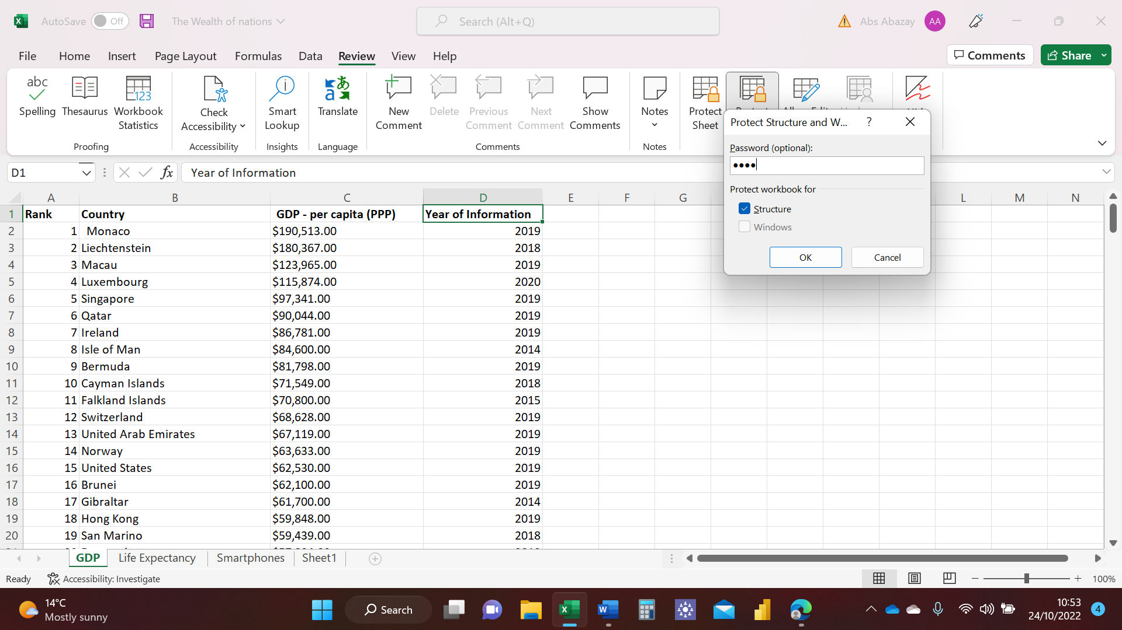

Step two is to highlight the C column and change currency from $ to £. I have pressed onto Currency then scrolled down to More Number Format and then selected the correct option. That’s shown on the pictures below.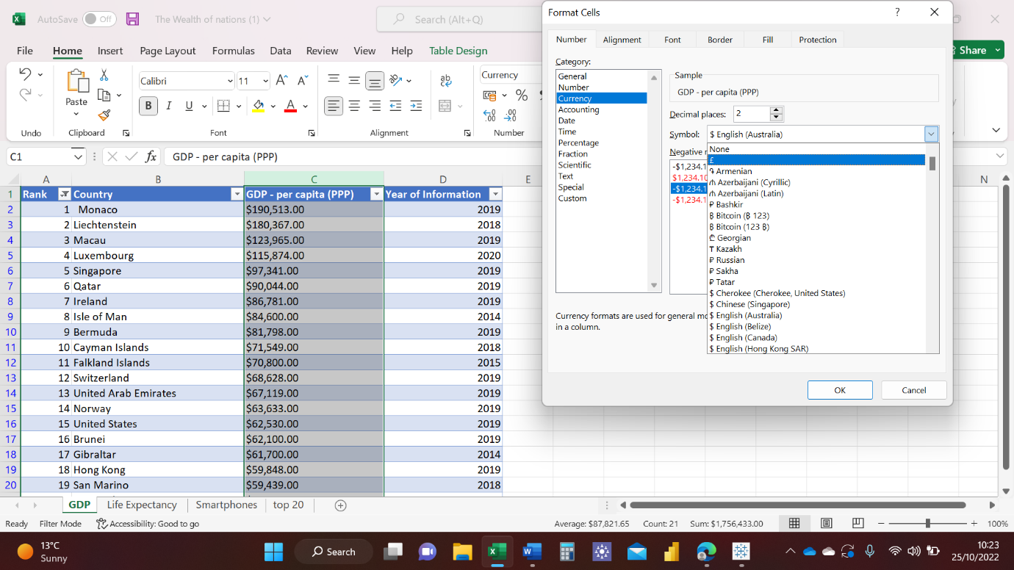

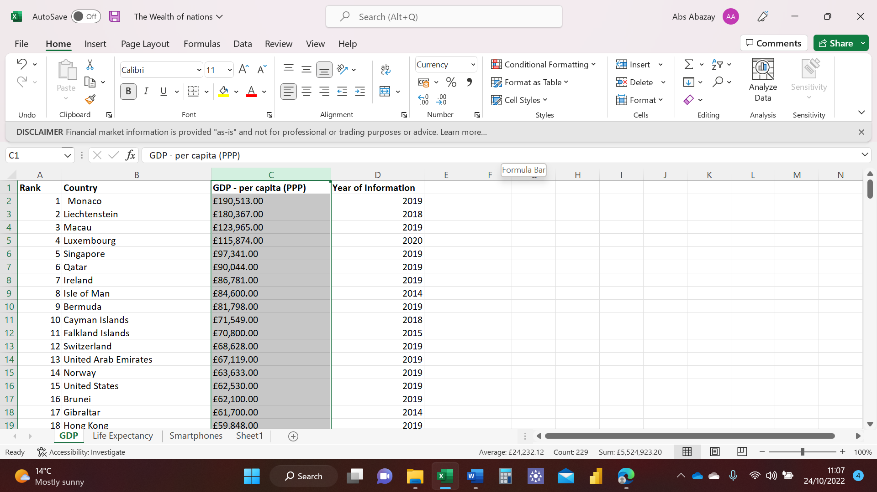

Step three is to turn the GDP sheet into table, I have also added the option to filter the data, see picture below. I have highlighted all the Data then pressed format as a table and chose the desired design.

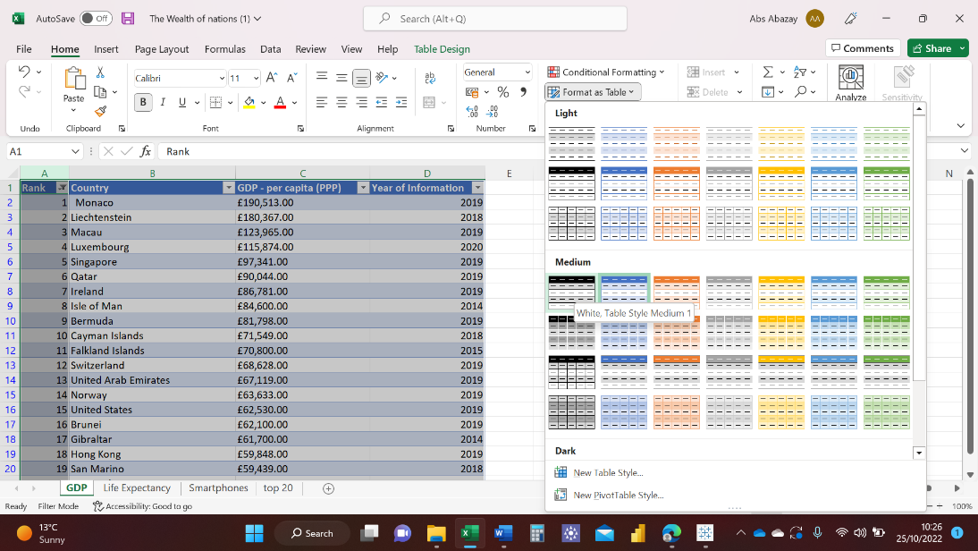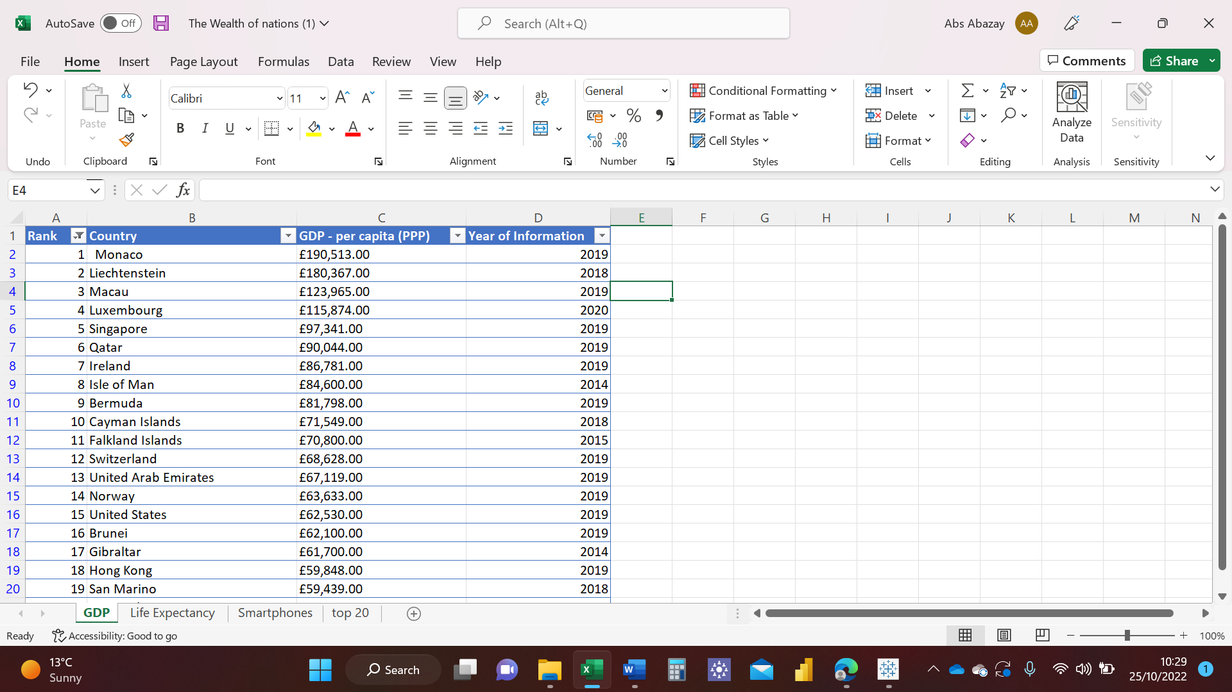

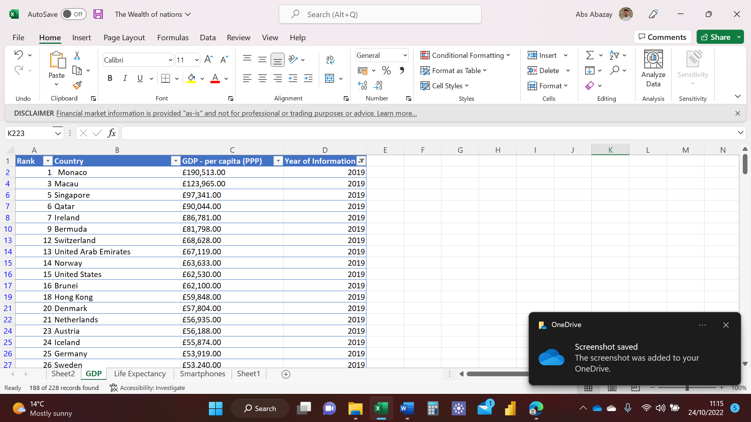Step four is to filter the data to show only year 2019. I have clicked onto the filter option and deselected all the years apart from 2019, see pictures below. 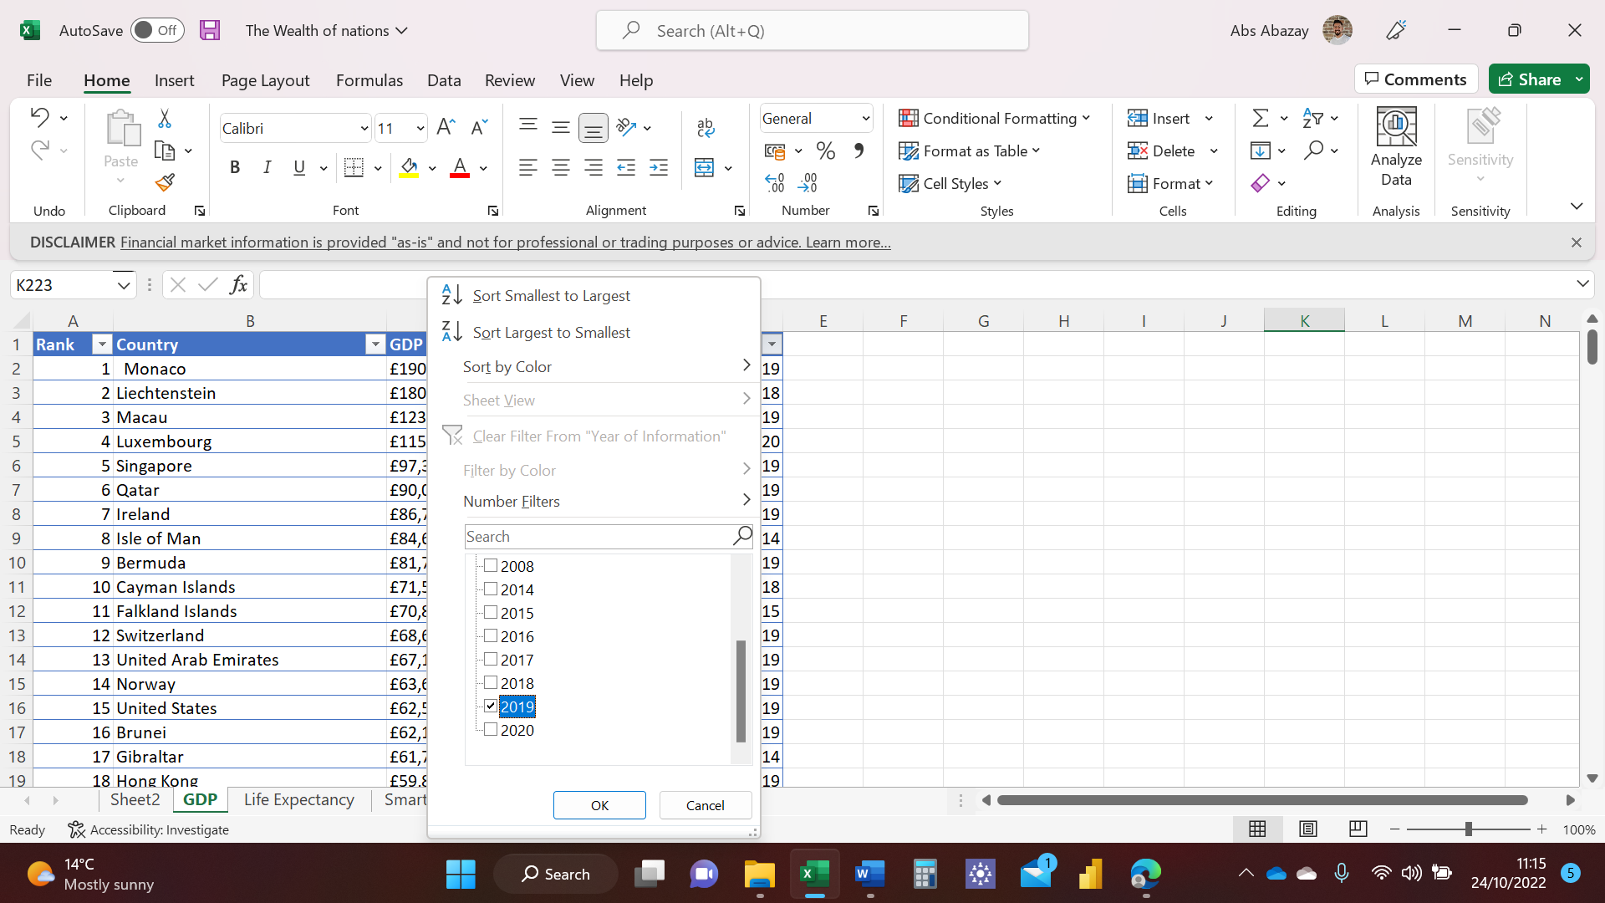

Step five is to create a chart that displays the Rank, Country, and GDP-per capita (PPP), To do this I have selected all the Data and pressed on Insert, then used the Recommended Charts option and chose the desired chart, see pictures below.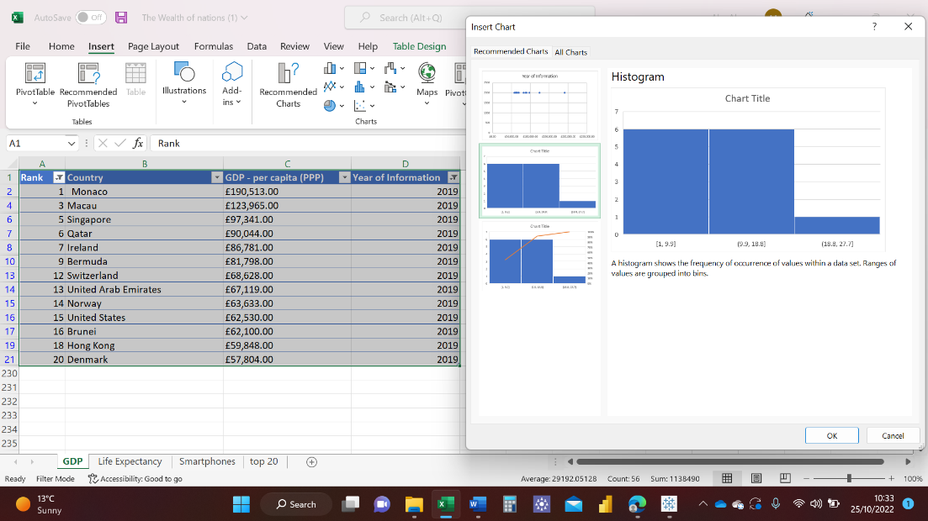\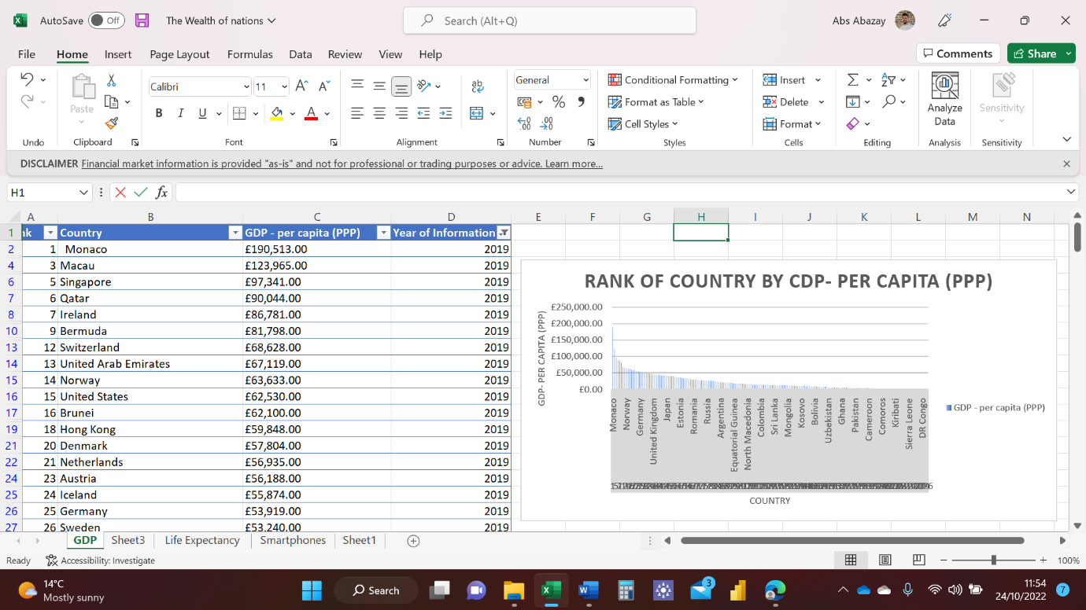

Step six is to edit the chart created. I have used the options available to edit the chart after double clicking onto the chart, see pictures below.

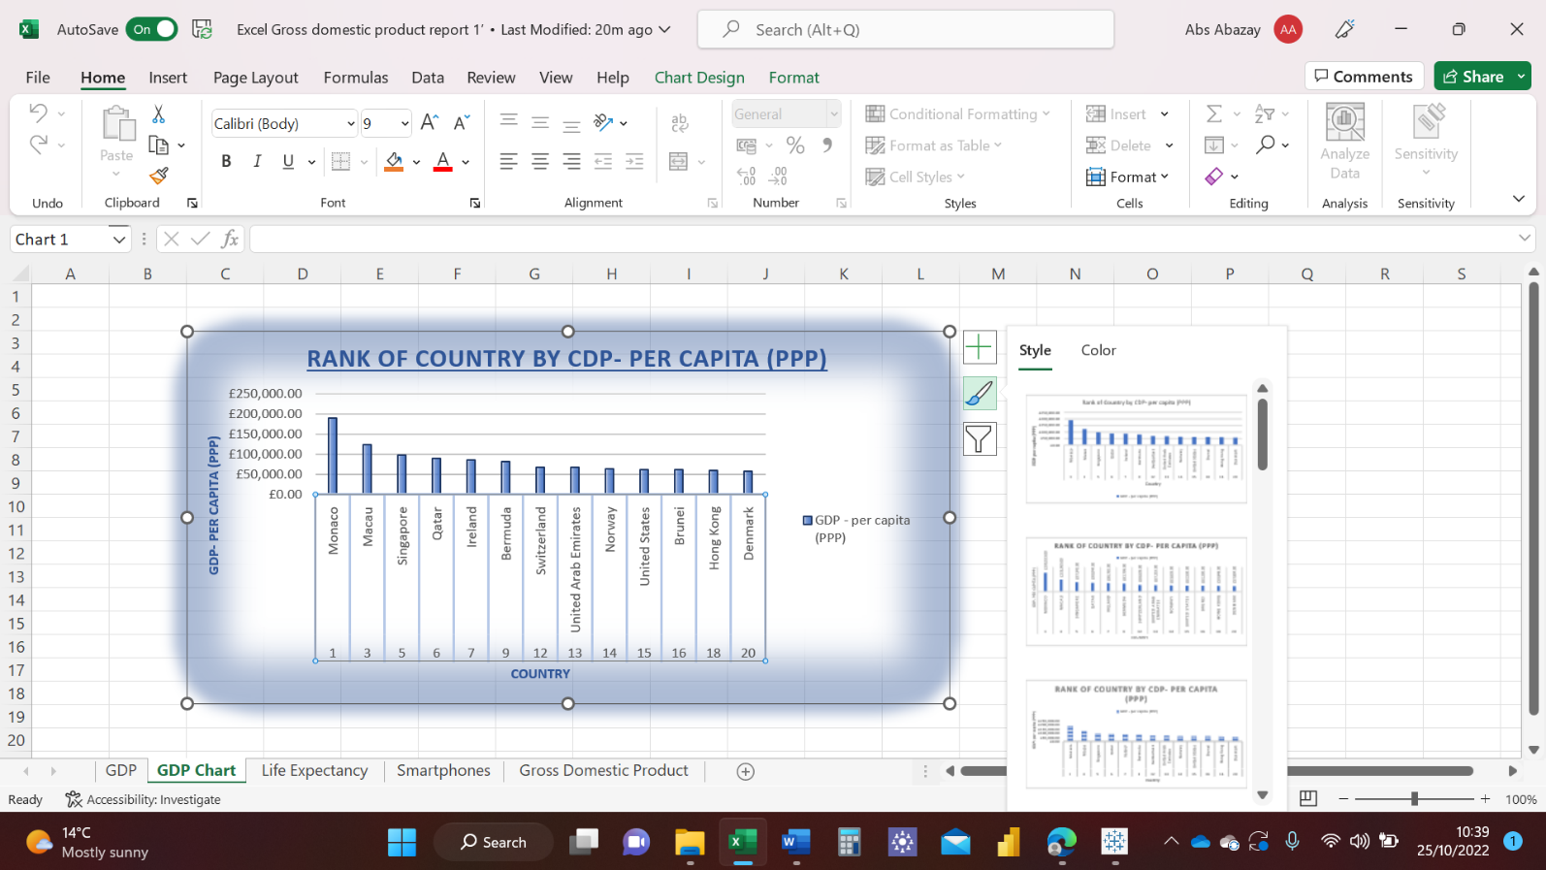

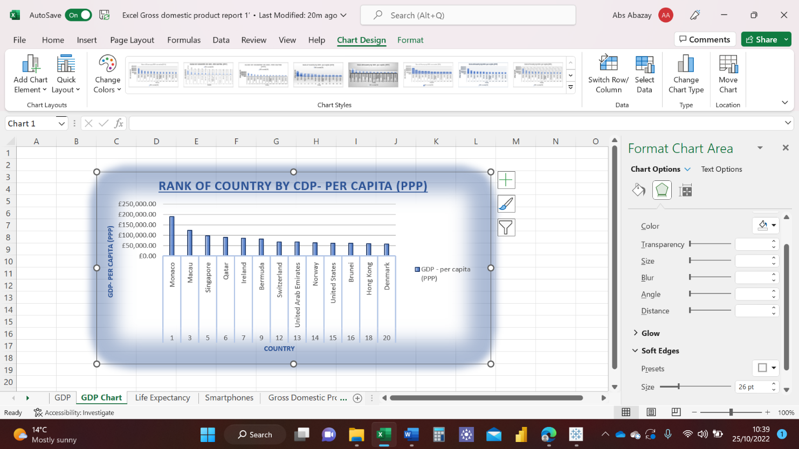

I have tried different designs such as the one pictured below.

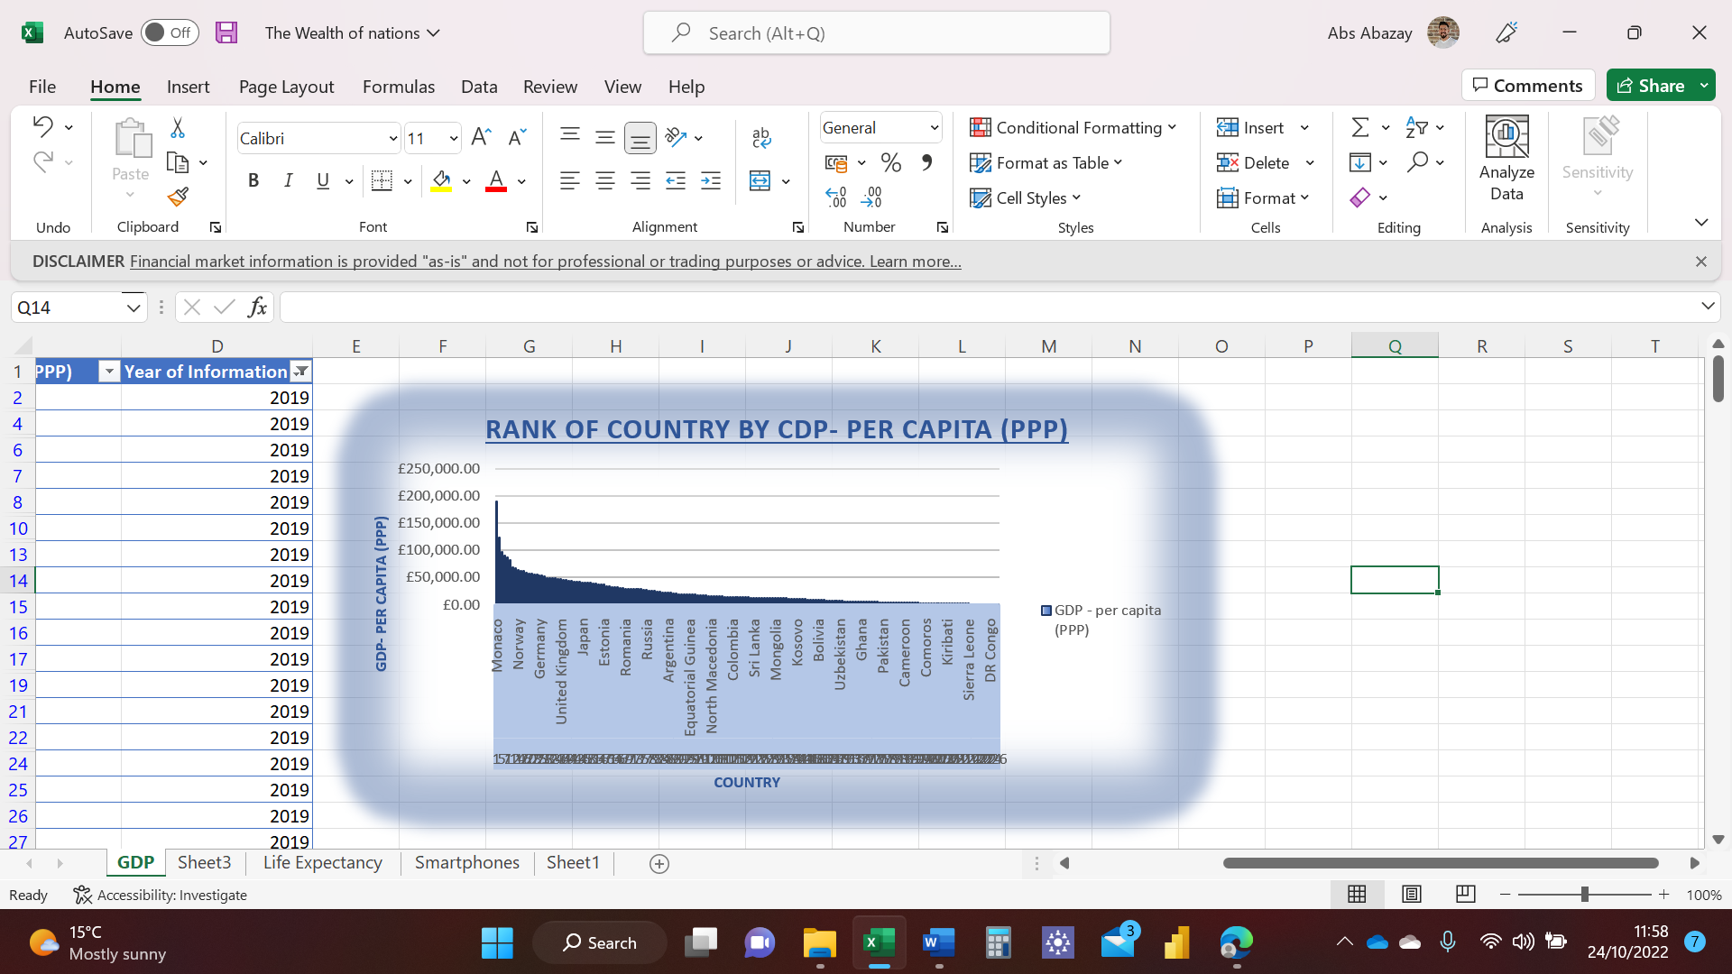

This is my result of the chart, see below.



Step seven is to move the chart to a new sheet tab and label with a suitable name. I have right clicked on the chart and used the Copy option. Then I have opened a new sheet and pasted it there. To rename the sheet I have right clicked on the new sheet tab and chose the Rename option. 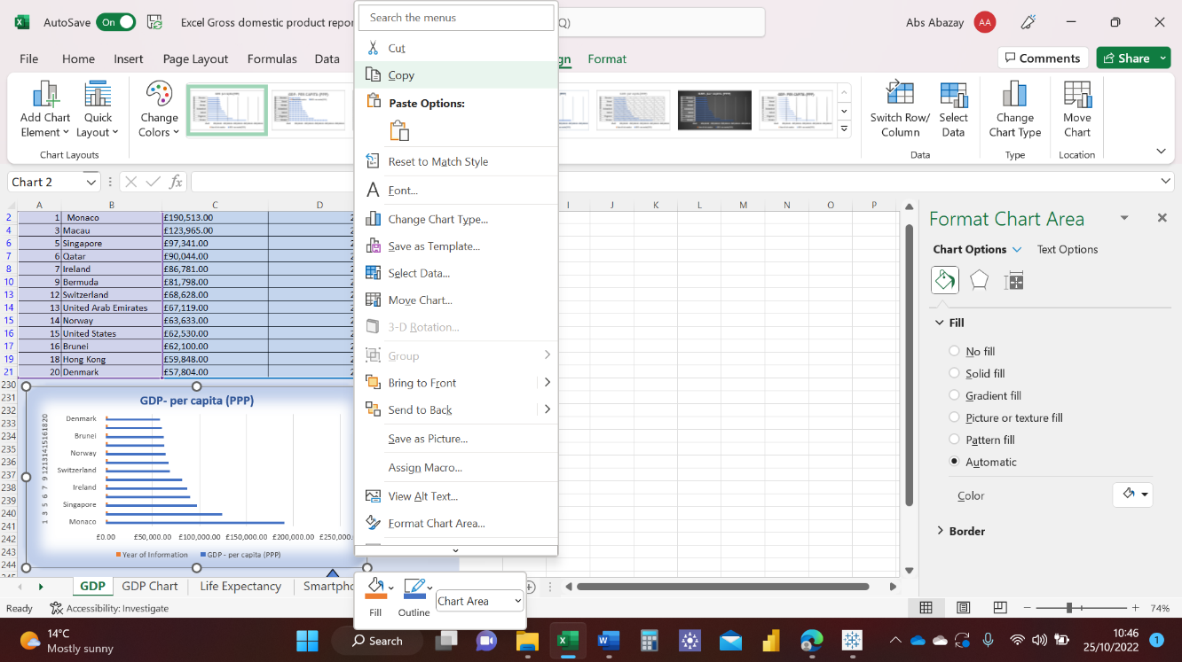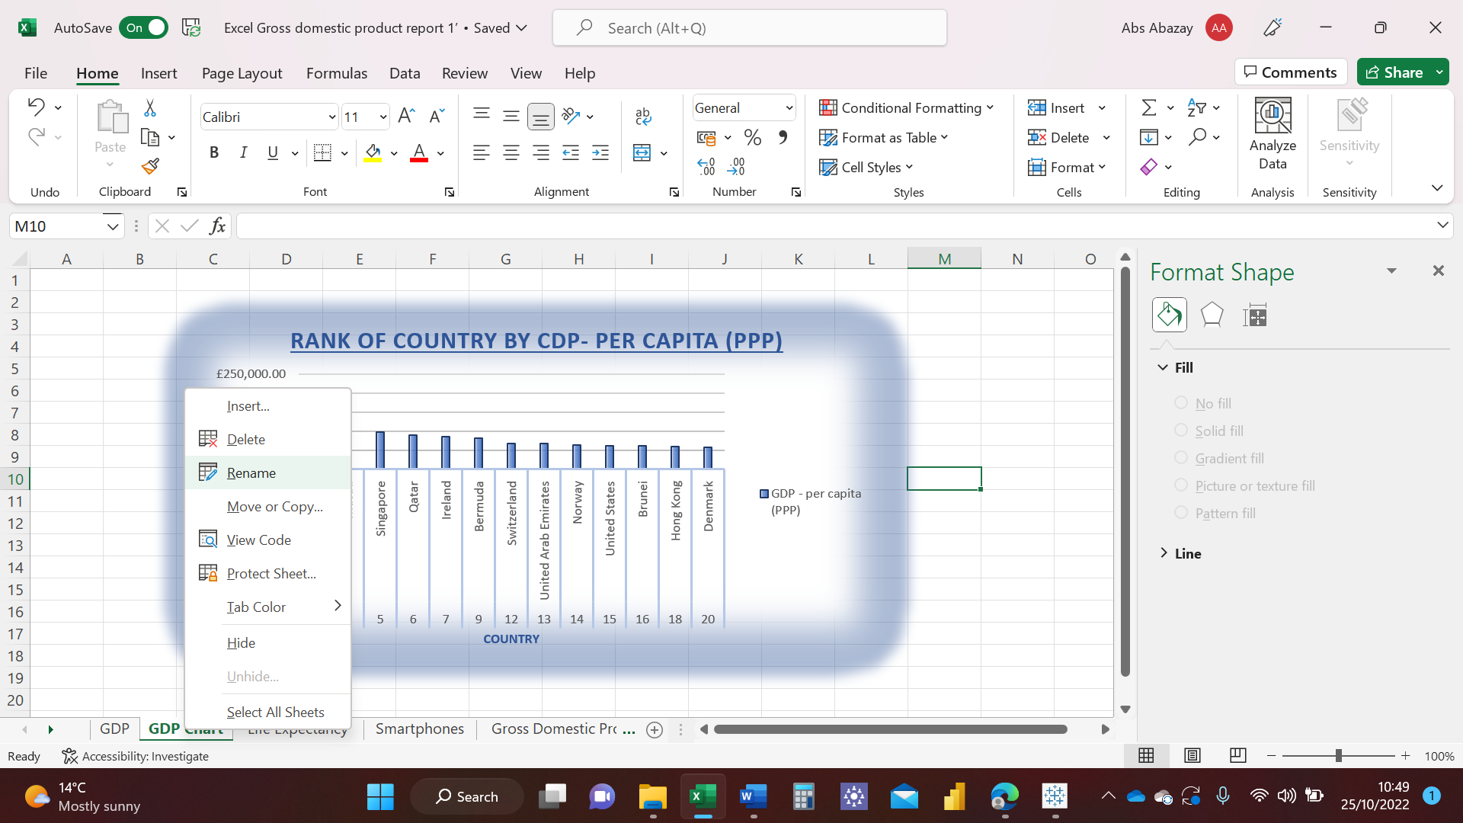

Step eight is to create a sort for the top 20 highest ranking countries, see picture below.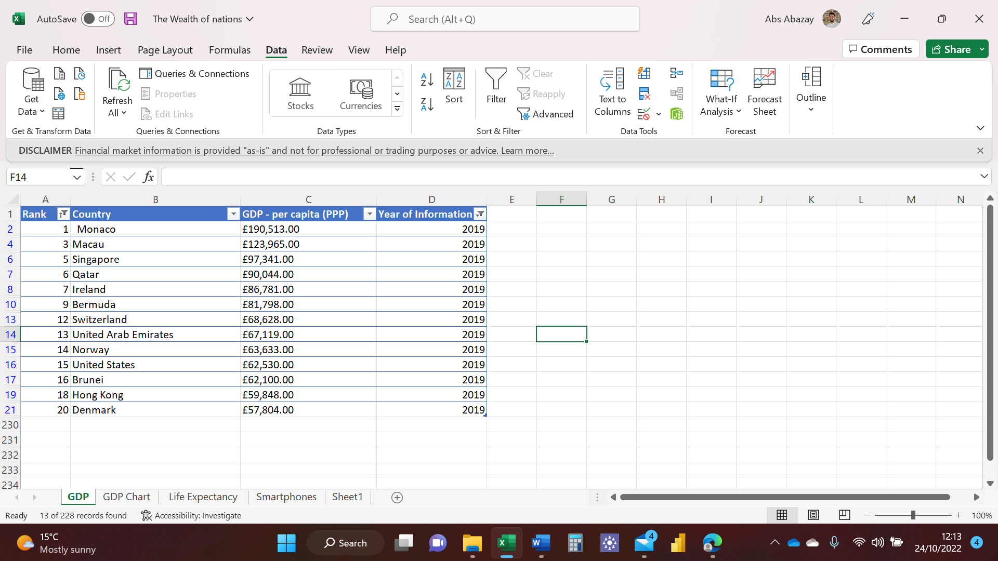

Step nine is to create a new Bar chart to display the 20 highest ranking countries displaying the table and chart underneath. I have followed the same step as before, highlighting the data then using the Recommended Charts option. See picture below.

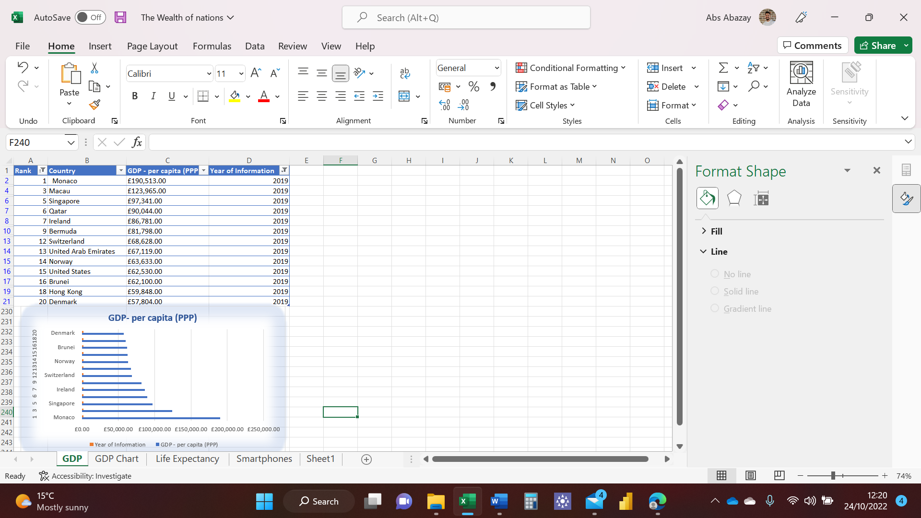

Step ten is to fill the background with a colour. I have right clicked on the background then used the fill in option to choose the desired colour, I have chosen light blue. See pictures below.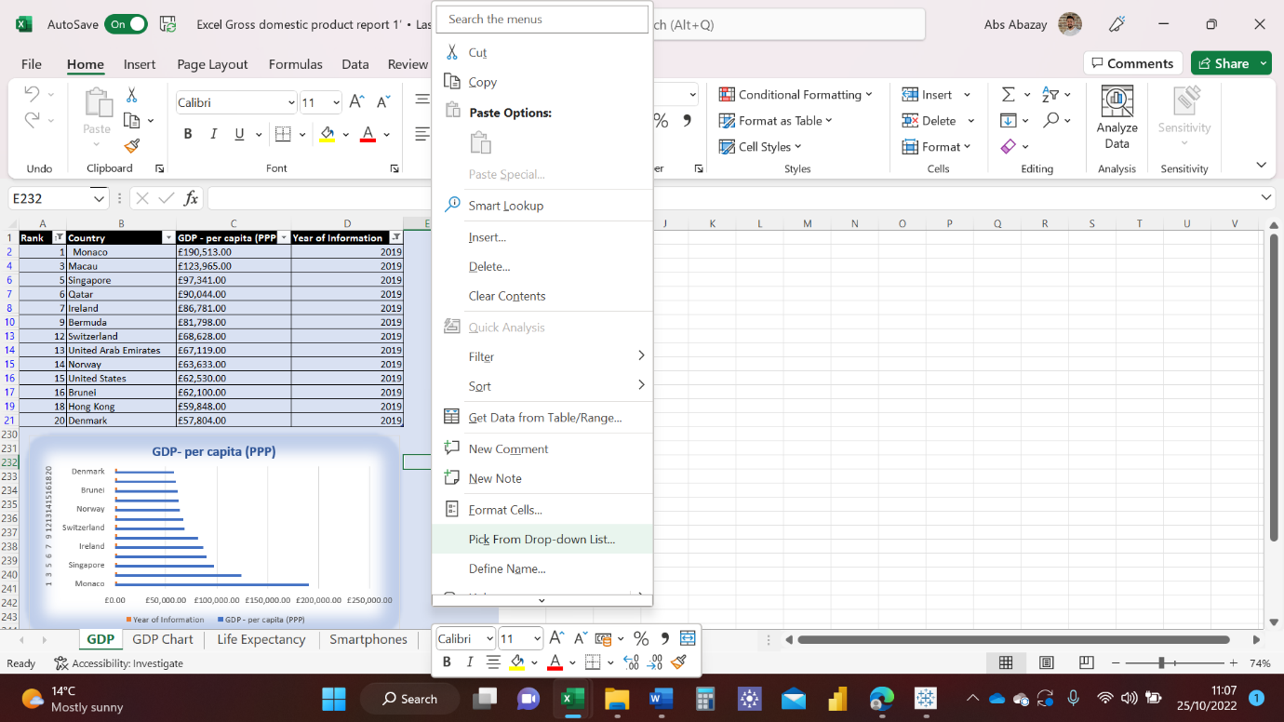 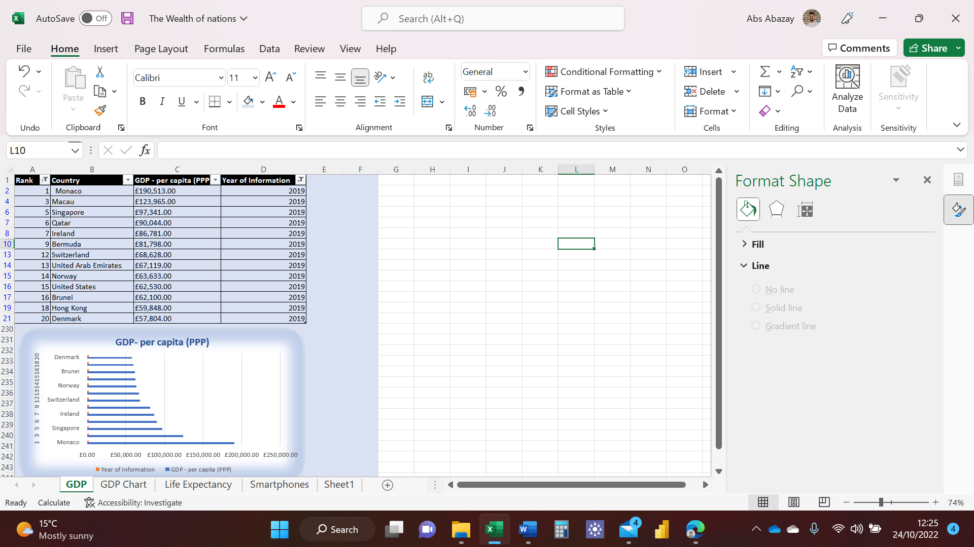

Step 11 is to create three macro buttons (Print, Save, Copy) see pictures below.

I have created the buttons by clicking on Illustration then choosing the desired shape and editing it to my liking. See picture on the right. 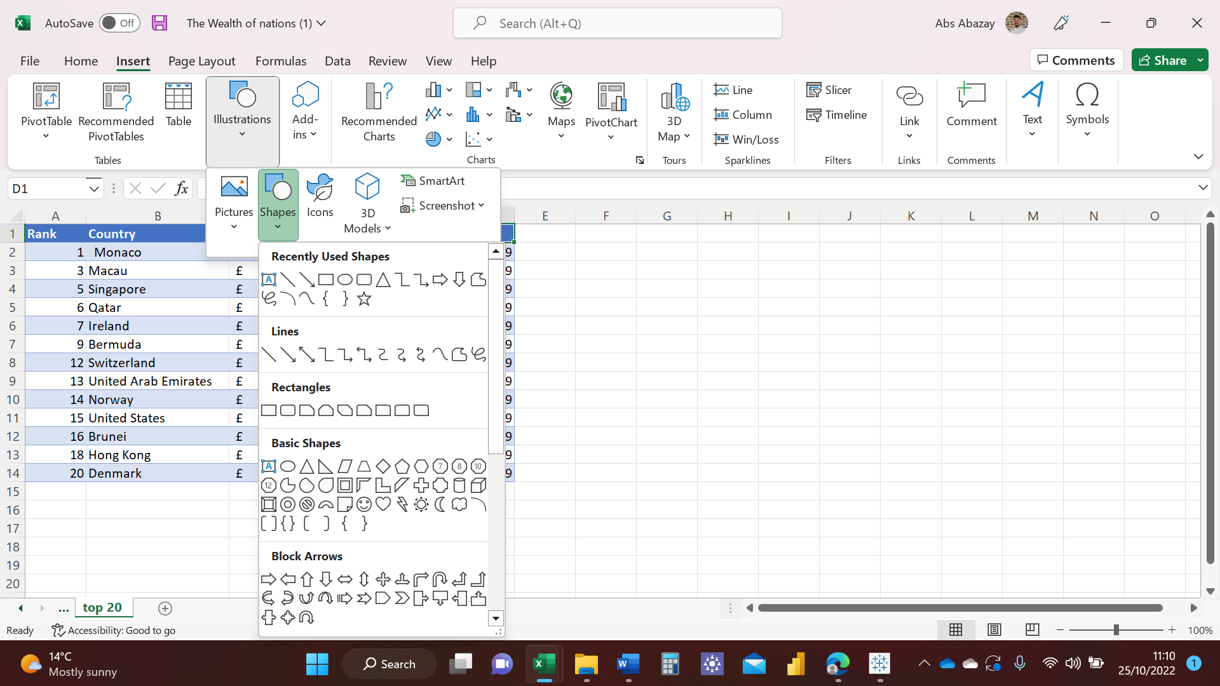

First step of creating a macro is to record the action you want the button to perform, in this case I am recording a printing action.

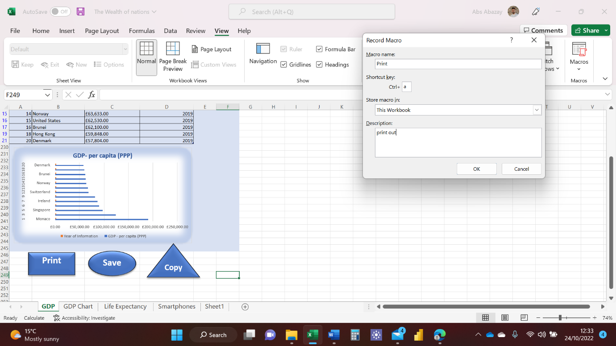

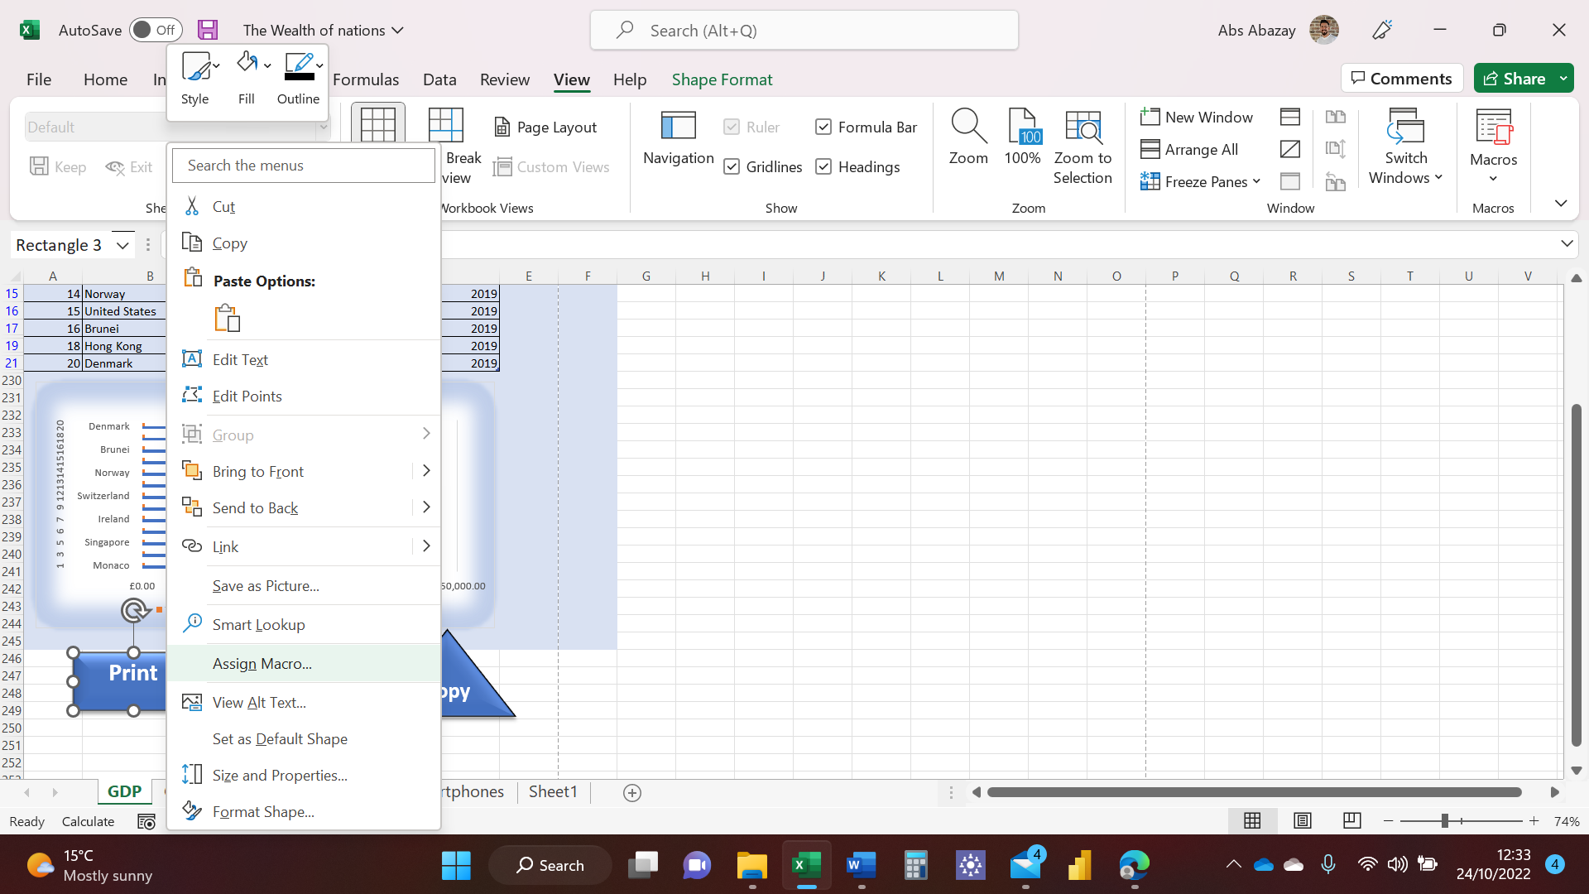

On these pictures. I am assigning the print macro I have created.

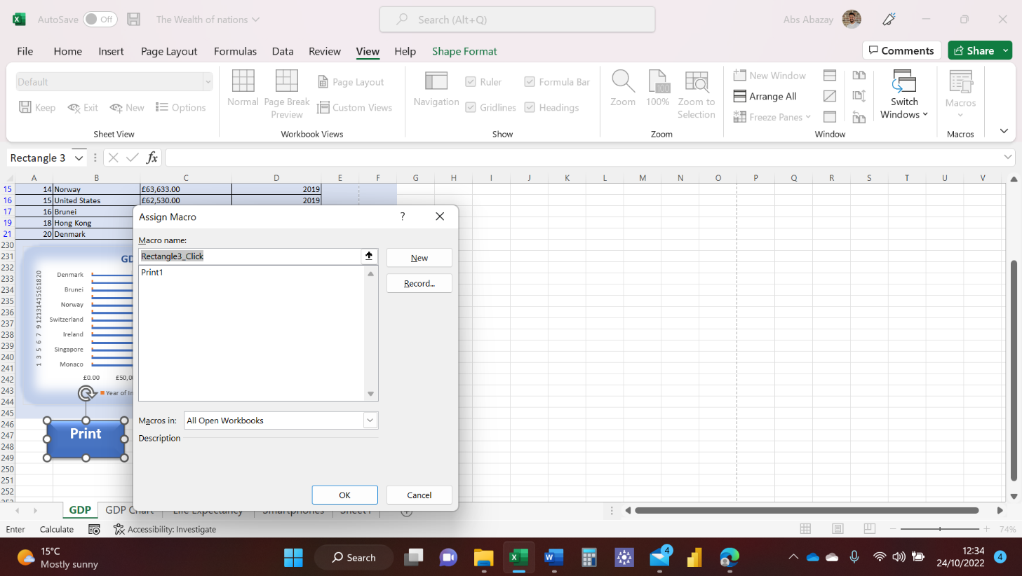

Now following the same steps, I am creating Save and Copy macros and assigning them to correct buttons.

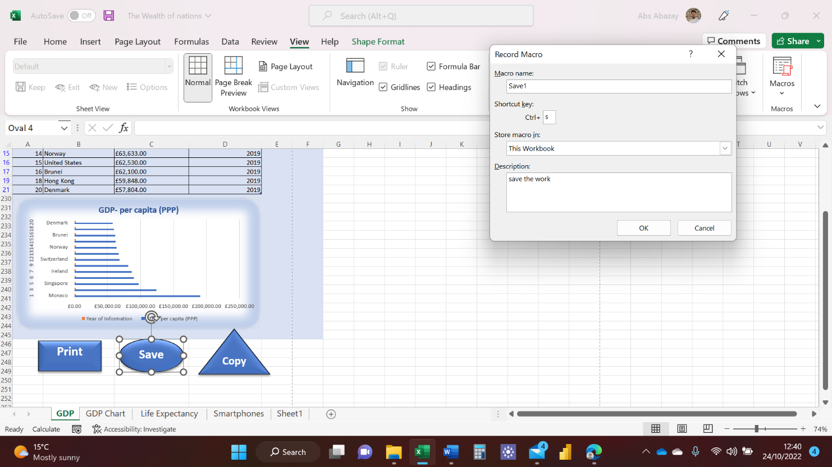

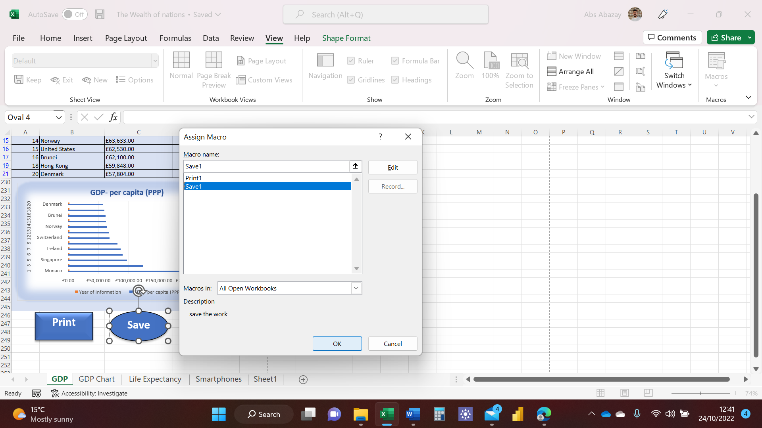

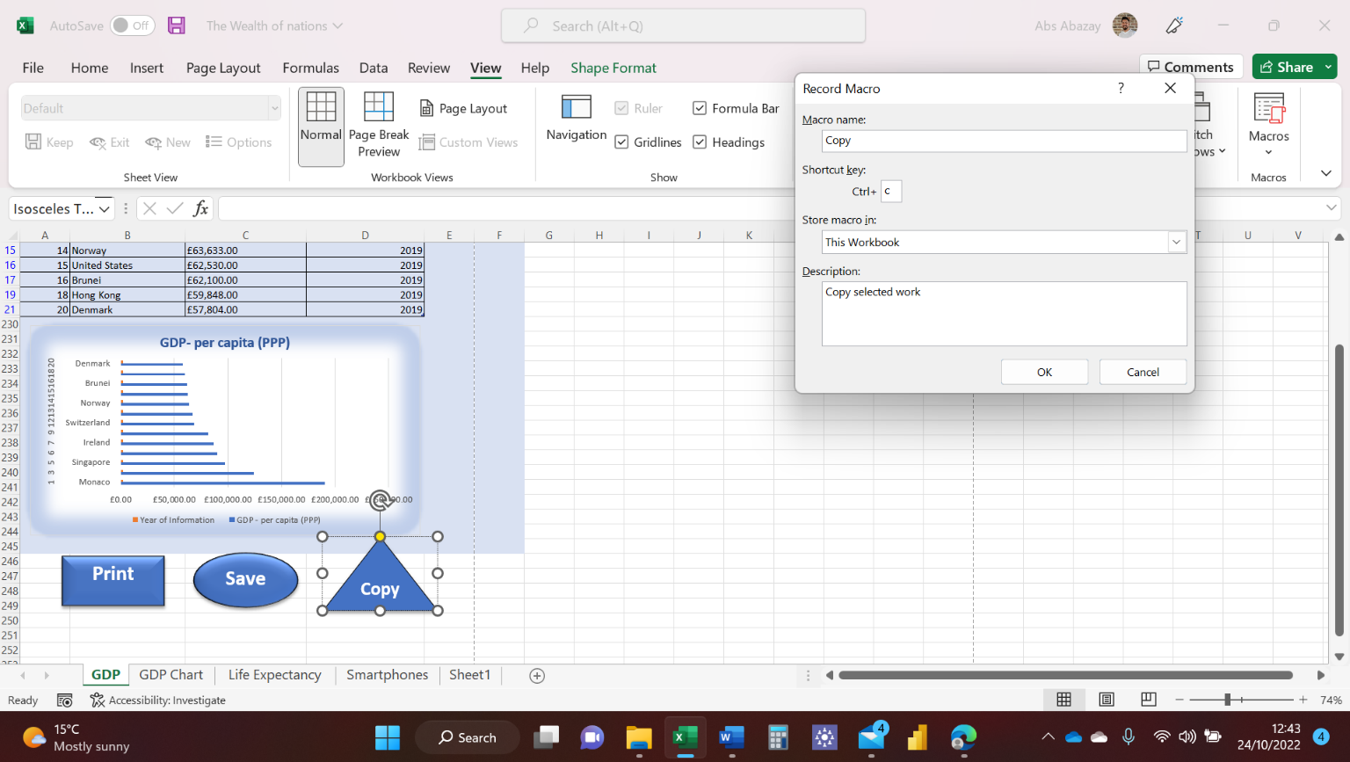

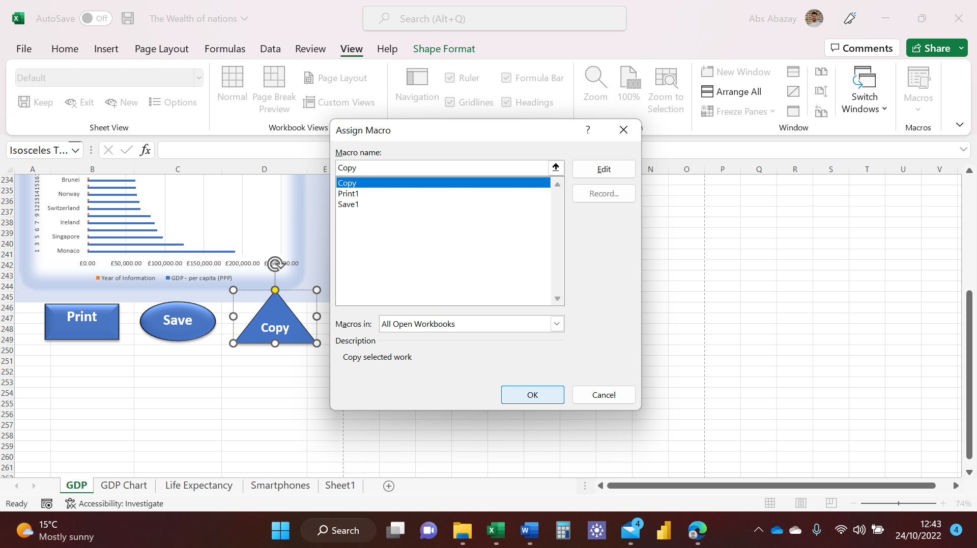

Step twelve is to copy the work using the macro copy button while keeping the format and renaming the new sheet, see picture below.

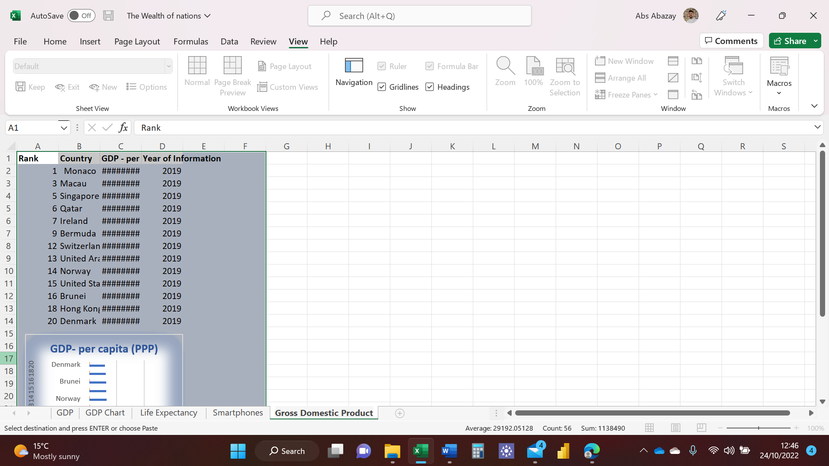

I have now added a header and footer to my Excel worksheet

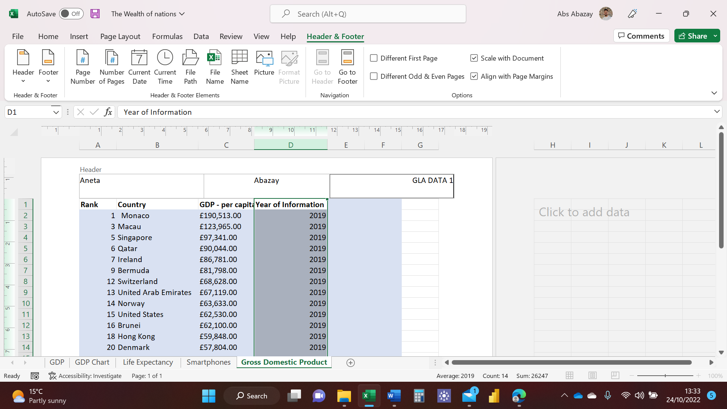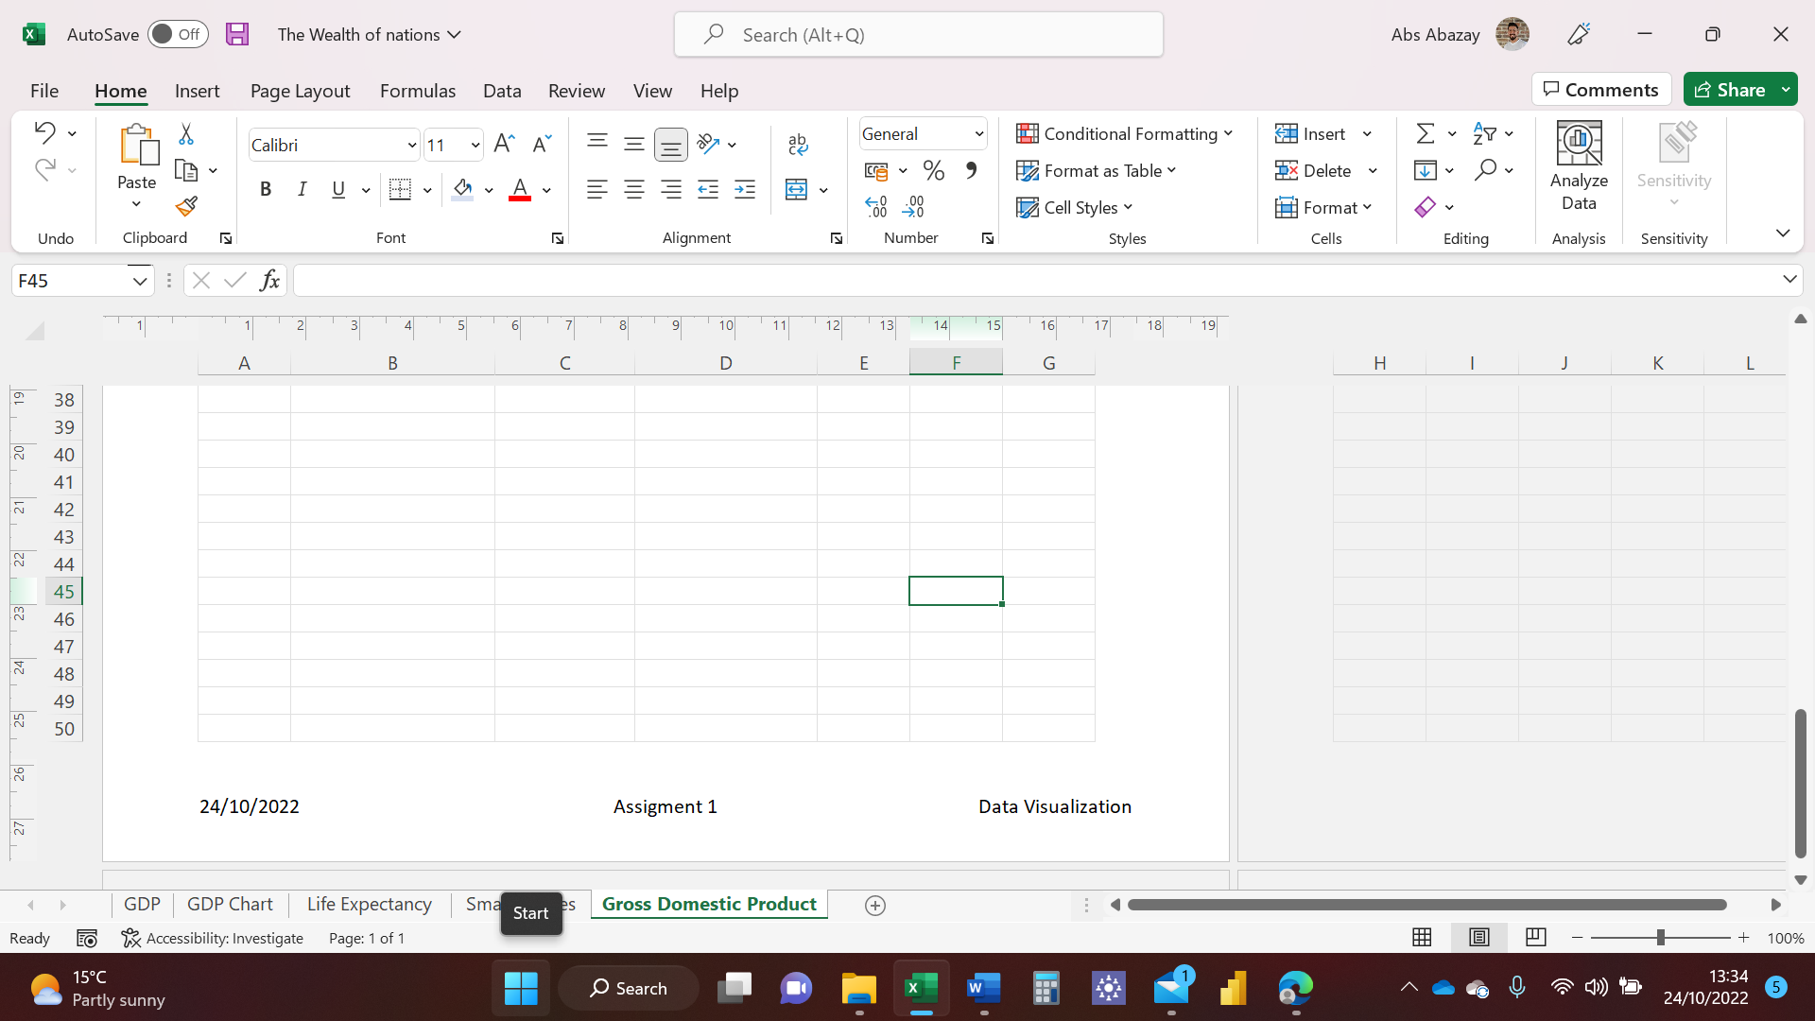

# 

# Task 3

I have now created a dashboard using Tableu.

Using the Excel data provided I have uploaded the data onto Tableu, I have set the relationship between the sheets as Country equals Country, because that’s what they have all had in common.

I have then created five different graphs and two maps to allow the client to see the Data in a visual that’s easy to read. I have applied filter to make sure only top 20 ranked Countries are displayed. I have then created a dashboard that is going to be shown to the client, I have uploaded four charts and a map that in my opinion are the best way to explain the Data to the client.

<https://public.tableau.com/views/WealthofNations_16666223216330/Dashboard1?:language=en-GB&publish=yes&:display_count=n&:origin=viz_share_link>

